Chapter 11, Problem 24.

Determine the rms value of the waveform in Fig. 11.55.

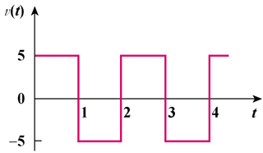

Figure 11.55
For Prob. 11.24.

